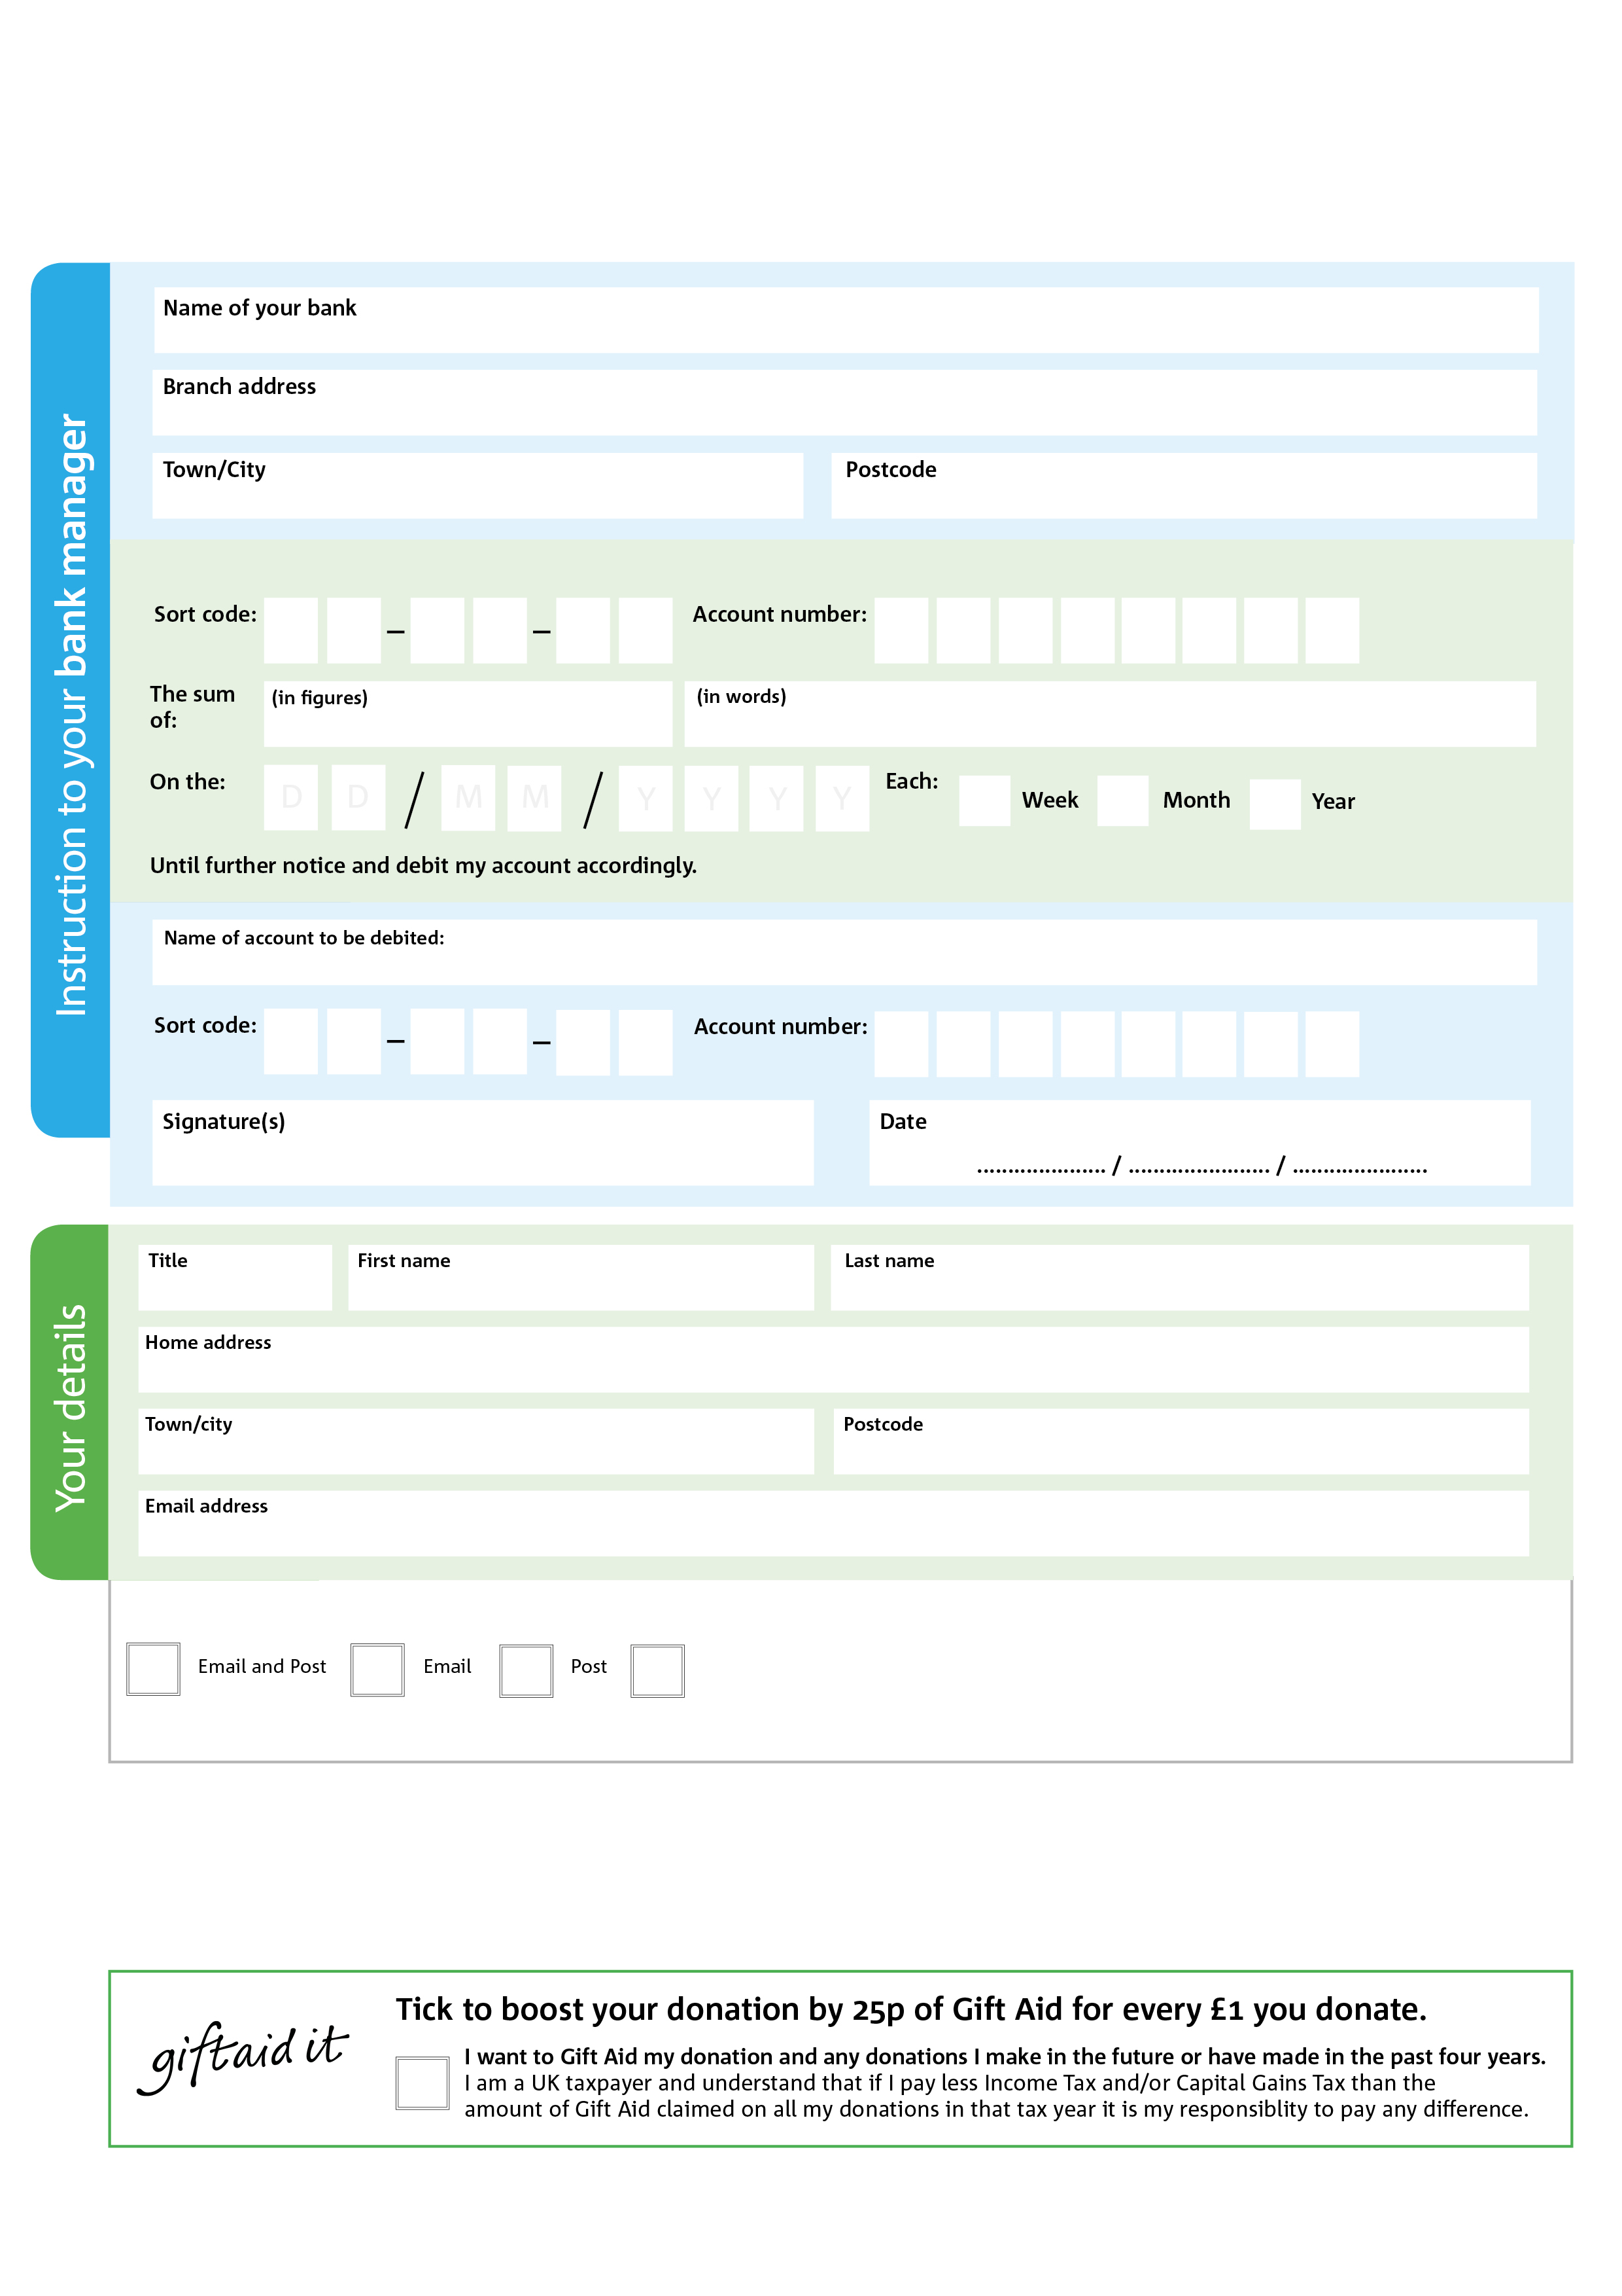

I do not wish to receive future communications from the   
 Foodbank

Please let us know how we may contact you

POSTAL ADDRESS: Towcester Foodbank, Pant-yr-Onen, Norton, Daventry, NN11 2NB

**Please pass this form onto the foodbank, using the foodbank’s address at the bottom, who will save a copy for their records. They will then send it onto your named bank or building society.**

0

V

9

V

7

V

9

V

6

V

1

V

3

V

0

V

4

4

7

5

0

2

Please pay Towcester Foodbank,

**Data protection**

Towcester Foodbank is committed to protecting your privacy and will process your personal data in accordance with current Data rotection legislation. Towcester Foodbank collects information to keep in touch with you and supply you with information relating to our work. Towcester Foodbank will never sell or pass your details to anyone who isn’t directly working on our behalf. A full Data Privacy statement for financial donors is available on request.

**One-off Gift**

**towcester.foodbank.org.uk**

Reg. Charity No: 1157338 Reg. in England & Wales

You can change your preferences any time by contacting us on XXXXXXXXXXX or emailing us at XXXX@XXXXXXXXXX.foodbank.org.uk

I do not wish to receive future communications from XXXXXX Foodbank